Eventi
Use Case Specification

Submitted to:

Asst. Prof. Ma. Rowena C. Solamo
Faculty Member
Department of Computer Science
College of Engineering
University of the Philippines, Diliman

Submitted by:
Dimaano, Aaron Diego I.
Lopez, Matthew S.
Torres, Jacob Angelo V.

In partial fulfillment of academic requirements
for the course
CS 191 Software Engineering I
of the
1st Semester, AY 2015-2016
Unique Reference:
The documents are stored in https://github.com/Tom-2013-06417/CS191-192_Event_Sharing/tree/master/02-Requirements%20Engineering.
Link to this document: https://github.com/Tom-2013-06417/CS191-192_Event_Sharing/blob/master/02-Requirements%20Engineering/8.0%20-%20View%20own%20profile.pdf.

Document Purpose:
The purpose of this document is to exhaust the step-by-step process of the Use Cases in every scenario possible.

Target Audience:
To our project client and adviser, our fellow 191 classmates, and our future selves when they need to refer back to this document.

Revision Control:

Revision Date | Person Responsible | Version  Number | Modification
09/18/15 | Dimaano, Diego  Lopez, Matthew  Torres, Jacob | 1.0 | Initial Document

Use-Case Name: View own profile

Description: See how others see your organization. This functionality allows the organization’s managers to see how they can improve the presentation of their organization to the viewer’s.

Preconditions: There is an internet connection to the Eventi server and a device with browsing capabilities. A registered user that has permission to operate an organization must be currently logged into the site.

Flow of Events:

Scenario Name | Description
Scenario 1 (Basic Flow)  View Organization’s Profile | 1. Registered User opens the Organization's profile  2. Registered User can now operate the Organization

Activity Diagram of the Flow of Events:

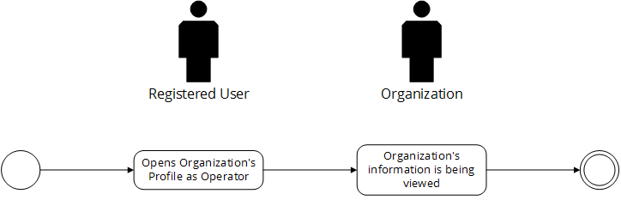

Post-conditions: Successful: The profile has successfully loaded and the details are shown.
Failed: The website did not load.

Special Requirements: NONE

